# Cvičenie 05- Hrašna, Suroviak

# Porovnanie QoS mechanizmov

Našou počiatočnou úlohou bolo podľa schémy zapojiť 2 routre a k nim pripojené 2 počítače podľa zadania. Podľa zadania sme ich aj nakonfigurovali a to konkrétne statické ip (statické smerovanie) pre routre aj PC, clock rate 128000, bandith 128.

**R1**

**R2**

**10.0.1.0 / 24**

**10.0.2.0 / 24**

**10.0.12.0 / 24**

**128 k**

**clock rate**

**bandwidth**

**Sender**

**Reciever, WS**

**S0**

**S0**

**f0**

**f0**

V tejto úlohe sme pozorovali zmenu hardvérového frontu smerovačov pri zmenách parametrov bandwidth a tx-ring-limit.

Konfigurácia:

Int s0/0/0

tx-ring-limit 4

* Po nastavení pozorujeme zmenu tx_limited = 0 (4);

výpis show controlllers s0/0/0:

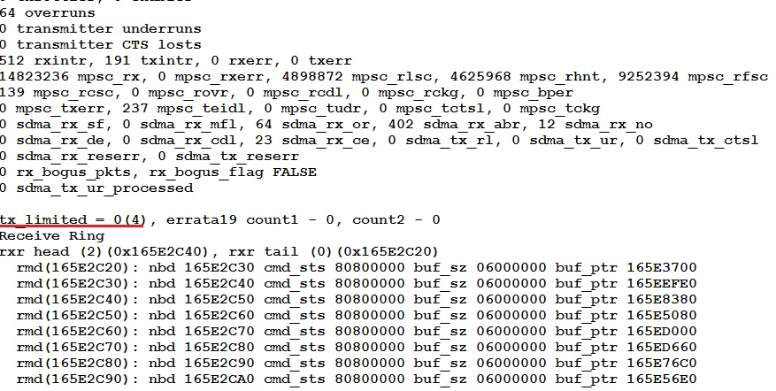

* Zmenou hodnoty bandwidth sme nepostrehli žiadnu zmenu

výpis show controlllers s0/0/0:

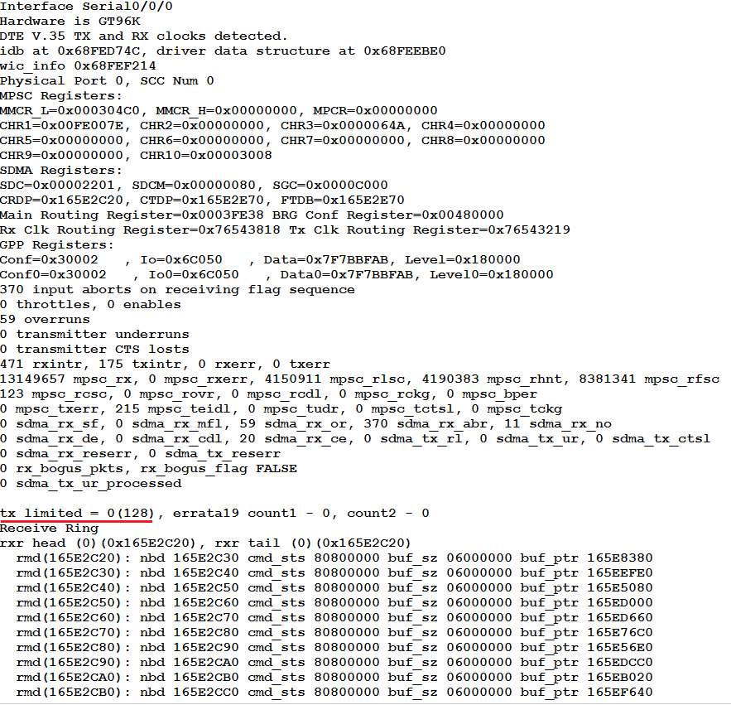

# Konfigurácia a testovanie stratégie FIFO

Scenár 1 – tok je pod kapacitou linky:

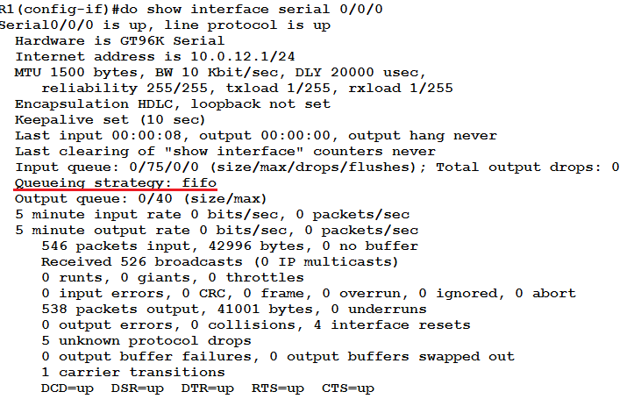

1. UDP tok: 10p/s, veľkosť paketu 512B/p = 40960b/s
2. UDP tok: 10p/s, veľkosť paketu 512B/p = 40960b/s

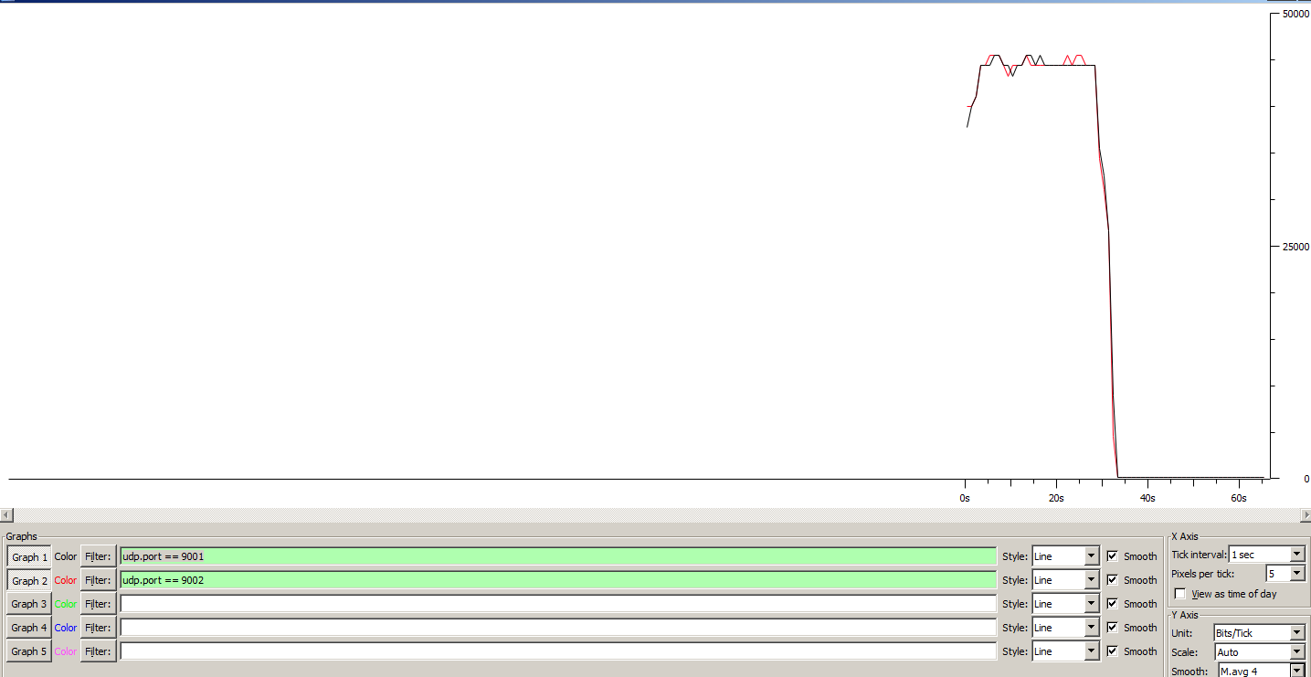

----------------------------------------------------------

Total time = 29.727000 s

Total packets = 300

Minimum delay = -12.454000 s

Maximum delay = -12.258000 s

Average delay = -12.356427 s

Average jitter = 0.004184 s

Delay standard deviation = 0.047678 s

Bytes received = 153600

Average bitrate = 41.336159 Kbit/s

Average packet rate = 10.091836 pkt/s

Packets dropped = 0 (0.00 %)

Average loss-burst size = 0.000000 pkt

----------------------------------------------------------

----------------------------------------------------------

Flow number: 1

From 10.0.1.2:61472

To 10.0.2.1:9001

----------------------------------------------------------

Total time = 29.723000 s

Total packets = 300

Minimum delay = -12.427000 s

Maximum delay = -12.225000 s

Average delay = -12.331640 s

Average jitter = 0.004849 s

Delay standard deviation = 0.047452 s

Bytes received = 153600

Average bitrate = 41.341722 Kbit/s

Average packet rate = 10.093194 pkt/s

Packets dropped = 0 (0.00 %)

Average loss-burst size = 0.000000 pkt

----------------------------------------------------------

__________________________________________________________

**************** TOTAL RESULTS ******************

__________________________________________________________

Number of flows = 2

Total time = 29.760000 s

Total packets = 600

Minimum delay = -12.454000 s

Maximum delay = -12.225000 s

Average delay = -12.344033 s

Average jitter = 0.005225 s

Delay standard deviation = 0.049153 s

Bytes received = 307200

Average bitrate = 82.580645 Kbit/s

Average packet rate = 20.161290 pkt/s

Packets dropped = 0 (0.00 %)

Average loss-burst size = 0 pkt

Error lines = 0

Scenár 2 – tok je nad kapacitou linky:

1. UDP tok: 30p/s, veľkosť paketu 512B/p = 122880b/s
2. UDP tok: 30p/s, veľkosť paketu 512B/p = 122880b/s

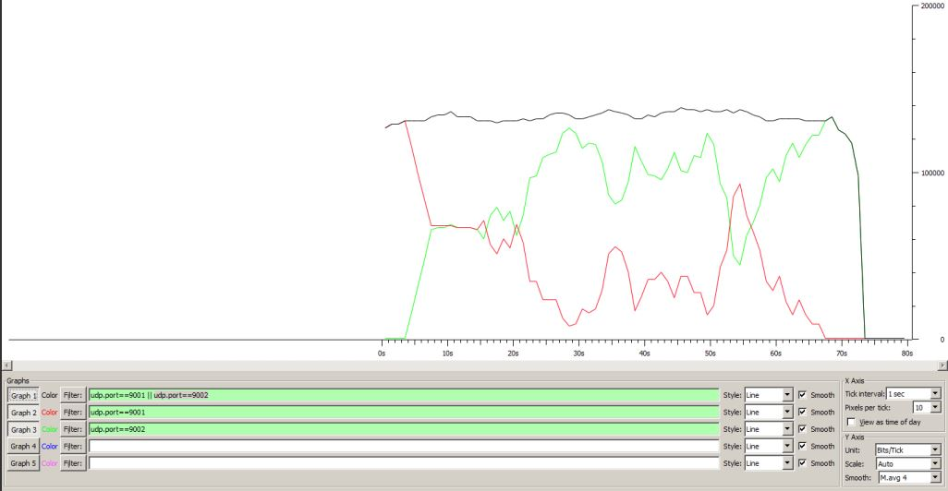

----------------------------------------------------------

Total time = 64.760000 s

Total packets = 718

Minimum delay = -12.235000 s

Maximum delay = -6.224000 s

Average delay = -8.283951 s

Average jitter = 0.010565 s

Delay standard deviation = 2.431097 s

Bytes received = 367616

Average bitrate = 45.412724 Kbit/s

Average packet rate = 11.087091 pkt/s

Packets dropped = 1054 (59.48 %)

Average loss-burst size = 11.094737 pkt

----------------------------------------------------------

----------------------------------------------------------

Flow number: 2

From 10.0.1.10:62270

To 10.0.2.10:9002

----------------------------------------------------------

Total time = 65.642000 s

Total packets = 1408

Minimum delay = -12.397000 s

Maximum delay = -6.501000 s

Average delay = -7.035661 s

Average jitter = 0.006524 s

Delay standard deviation = 1.105704 s

Bytes received = 720896

Average bitrate = 87.857896 Kbit/s

Average packet rate = 21.449682 pkt/s

Packets dropped = 392 (21.78 %)

Average loss-burst size = 4.083333 pkt

----------------------------------------------------------

__________________________________________________________

**************** TOTAL RESULTS ******************

__________________________________________________________

Number of flows = 2

Total time = 70.669000 s

Total packets = 2126

Minimum delay = -12.397000 s

Maximum delay = -6.224000 s

Average delay = -7.457238 s

Average jitter = 0.012694 s

Delay standard deviation = 1.776017 s

Bytes received = 1088512

Average bitrate = 123.223705 Kbit/s

Average packet rate = 30.083912 pkt/s

Packets dropped = 1446 (40.48 %)

Average loss-burst size = 7.570681 pkt

Error lines = 0

# Konfigurácia a testovanie stratégie Priority Queuing

Konfiguracia:

Access-list 101 permit udp any any eq 9001

Access-list 102 permit udp any any eq 9002

Class-map match-all pri1

Match access-group 101

Class-map match-all pri2

Match access-group 102

Policy-map qos

Class pri1

Priority level1

Class pri2

Priority level 2

Int s0/0/0

Service-policy output qos

Scenár 1 – tok je pod kapacitou linky:

1. UDP tok: 8p/s, veľkosť paketu 512B/p = 32768b/s
2. UDP tok: 8p/s, veľkosť paketu 512B/p = 32768b/s

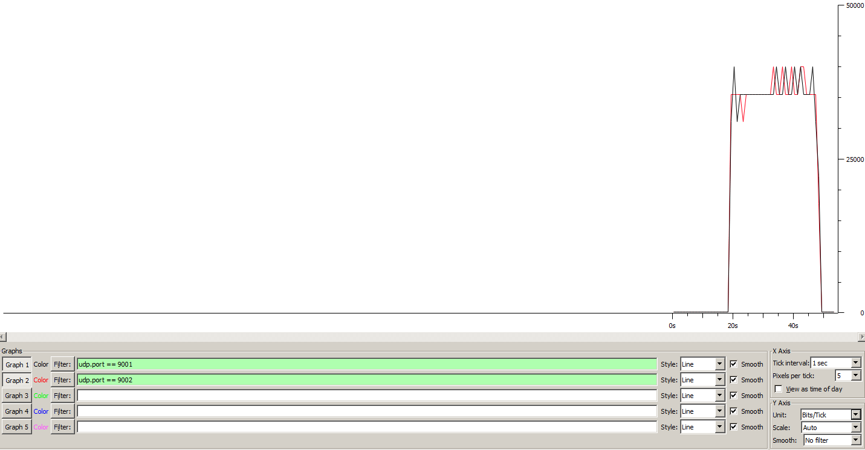

----------------------------------------------------------

Total time = 29.418000 s

Total packets = 240

Minimum delay = -14.122000 s

Maximum delay = -13.489000 s

Average delay = -13.717425 s

Average jitter = 0.005695 s

Delay standard deviation = 0.211934 s

Bytes received = 122880

Average bitrate = 33.416276 Kbit/s

Average packet rate = 8.158270 pkt/s

Packets dropped = 0 (0.00 %)

Average loss-burst size = 0.000000 pkt

----------------------------------------------------------

----------------------------------------------------------

Flow number: 1

From 10.0.1.2:49671

To 10.0.2.1:9001

----------------------------------------------------------

Total time = 29.414000 s

Total packets = 240

Minimum delay = -14.095000 s

Maximum delay = -13.464000 s

Average delay = -13.688796 s

Average jitter = 0.005669 s

Delay standard deviation = 0.212204 s

Bytes received = 122880

Average bitrate = 33.420820 Kbit/s

Average packet rate = 8.159380 pkt/s

Packets dropped = 0 (0.00 %)

Average loss-burst size = 0.000000 pkt

----------------------------------------------------------

__________________________________________________________

**************** TOTAL RESULTS ******************

__________________________________________________________

Number of flows = 2

Total time = 29.450000 s

Total packets = 480

Minimum delay = -14.122000 s

Maximum delay = -13.464000 s

Average delay = -13.703110 s

Average jitter = 0.007357 s

Delay standard deviation = 0.212552 s

Bytes received = 245760

Average bitrate = 66.759932 Kbit/s

Average packet rate = 16.298812 pkt/s

Packets dropped = 0 (0.00 %)

Average loss-burst size = 0 pkt

Error lines = 0

Scenár 2 – tok je nad kapacitou linky:

1. UDP tok: 30p/s, veľkosť paketu 512B/p = 122880b/s
2. UDP tok: 30p/s, veľkosť paketu 512B/p = 122880b/s

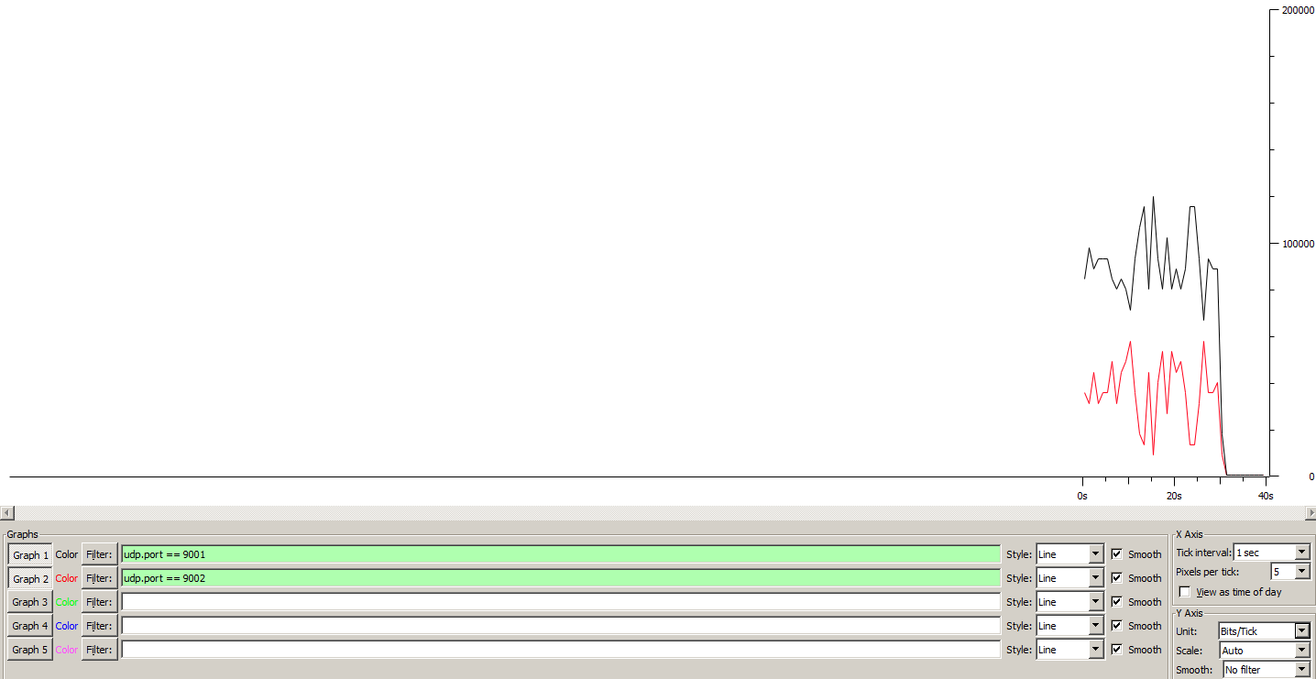

----------------------------------------------------------

Total time = 30.125000 s

Total packets = 621

Minimum delay = -13.595000 s

Maximum delay = -13.389000 s

Average delay = -13.521246 s

Average jitter = 0.009042 s

Delay standard deviation = 0.040056 s

Bytes received = 317952

Average bitrate = 84.435386 Kbit/s

Average packet rate = 20.614108 pkt/s

Packets dropped = 279 (31.00 %)

Average loss-burst size = 2.583333 pkt

----------------------------------------------------------

----------------------------------------------------------

Flow number: 2

From 10.0.1.2:50466

To 10.0.2.1:9002

----------------------------------------------------------

Total time = 30.054000 s

Total packets = 248

Minimum delay = -13.594000 s

Maximum delay = -13.400000 s

Average delay = -13.512581 s

Average jitter = 0.014571 s

Delay standard deviation = 0.041432 s

Bytes received = 126976

Average bitrate = 33.799428 Kbit/s

Average packet rate = 8.251813 pkt/s

Packets dropped = 651 (72.41 %)

Average loss-burst size = 5.564103 pkt

----------------------------------------------------------

__________________________________________________________

**************** TOTAL RESULTS ******************

__________________________________________________________

Number of flows = 2

Total time = 30.125000 s

Total packets = 869

Minimum delay = -13.595000 s

Maximum delay = -13.389000 s

Average delay = -13.518773 s

Average jitter = 0.011058 s

Delay standard deviation = 0.040643 s

Bytes received = 444928

Average bitrate = 118.155154 Kbit/s

Average packet rate = 28.846473 pkt/s

Packets dropped = 930 (51.70 %)

Average loss-burst size = 4.133333 pkt

Error lines = 0

# Konfigurácia a testovanie stratégie Weighted Fair Queuing

Konfiguracia:

Policy-map WFQ

Class class-default

Fair-queue

Int s0/0/0

Service-policy output WFQ

Scenár 1 – tok je pod kapacitou linky:

1. UDP tok: 8p/s, veľkosť paketu 512B/p = 32768b/s
2. UDP tok: 8p/s, veľkosť paketu 512B/p = 32768b/s

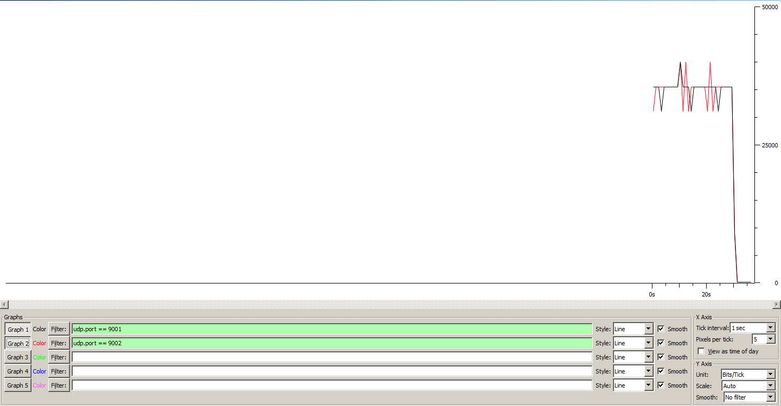

----------------------------------------------------------

Total time = 30.117000 s

Total packets = 240

Minimum delay = -13.577000 s

Maximum delay = -13.321000 s

Average delay = -13.478208 s

Average jitter = 0.004494 s

Delay standard deviation = 0.069433 s

Bytes received = 122880

Average bitrate = 32.640701 Kbit/s

Average packet rate = 7.968921 pkt/s

Packets dropped = 0 (0.00 %)

Average loss-burst size = 0.000000 pkt

----------------------------------------------------------

----------------------------------------------------------

Flow number: 2

From 10.0.1.2:49692

To 10.0.2.1:9002

----------------------------------------------------------

Total time = 30.117000 s

Total packets = 240

Minimum delay = -13.557000 s

Maximum delay = -13.302000 s

Average delay = -13.459504 s

Average jitter = 0.005213 s

Delay standard deviation = 0.069486 s

Bytes received = 122880

Average bitrate = 32.640701 Kbit/s

Average packet rate = 7.968921 pkt/s

Packets dropped = 0 (0.00 %)

Average loss-burst size = 0.000000 pkt

----------------------------------------------------------

__________________________________________________________

**************** TOTAL RESULTS ******************

__________________________________________________________

Number of flows = 2

Total time = 30.152000 s

Total packets = 480

Minimum delay = -13.577000 s

Maximum delay = -13.302000 s

Average delay = -13.468856 s

Average jitter = 0.005618 s

Delay standard deviation = 0.070086 s

Bytes received = 245760

Average bitrate = 65.205625 Kbit/s

Average packet rate = 15.919342 pkt/s

Packets dropped = 0 (0.00 %)

Average loss-burst size = 0 pkt

Error lines = 0

Scenár 2 – tok je nad kapacitou linky:

1. UDP tok: 30p/s, veľkosť paketu 512B/p = 122880b/s
2. UDP tok: 30p/s, veľkosť paketu 512B/p = 122880b/s

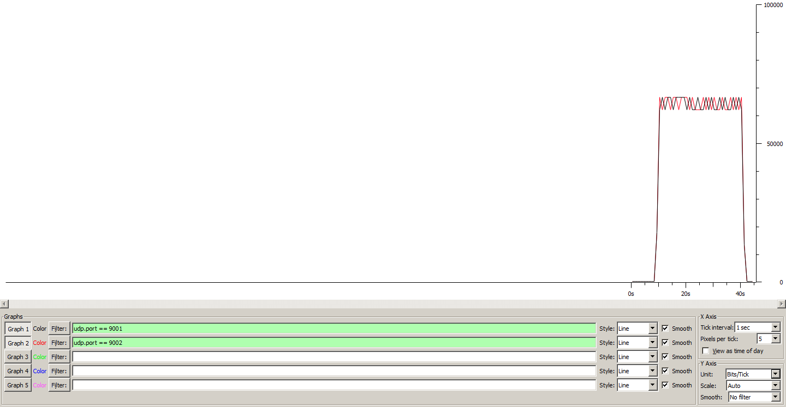

----------------------------------------------------------

Total time = 30.256000 s

Total packets = 440

Minimum delay = -12.791000 s

Maximum delay = -11.367000 s

Average delay = -11.600986 s

Average jitter = 0.009041 s

Delay standard deviation = 0.220240 s

Bytes received = 225280

Average bitrate = 59.566367 Kbit/s

Average packet rate = 14.542570 pkt/s

Packets dropped = 427 (49.25 %)

Average loss-burst size = 1.094872 pkt

----------------------------------------------------------

----------------------------------------------------------

Flow number: 1

From 10.0.1.2:49708

To 10.0.2.1:9001

----------------------------------------------------------

Total time = 31.239000 s

Total packets = 454

Minimum delay = -12.784000 s

Maximum delay = -11.378000 s

Average delay = -11.605242 s

Average jitter = 0.009276 s

Delay standard deviation = 0.216317 s

Bytes received = 232448

Average bitrate = 59.527642 Kbit/s

Average packet rate = 14.533116 pkt/s

Packets dropped = 442 (49.33 %)

Average loss-burst size = 1.091358 pkt

----------------------------------------------------------

__________________________________________________________

**************** TOTAL RESULTS ******************

__________________________________________________________

Number of flows = 2

Total time = 31.264000 s

Total packets = 894

Minimum delay = -12.791000 s

Maximum delay = -11.367000 s

Average delay = -11.603148 s

Average jitter = 0.010980 s

Delay standard deviation = 0.218267 s

Bytes received = 457728

Average bitrate = 117.125896 Kbit/s

Average packet rate = 28.595189 pkt/s

Packets dropped = 869 (49.29 %)

Average loss-burst size = 1.093082 pkt

Error lines = 0